**University of engineering & technology Peshawar**



**Circuit & system-1**

**Lab report # 13**

**Fall 2020**

**Submitted by: Ashfaq Ahmad**

**Section: B**

**Reg No: 19PWCSE1795**

**Semester: 2nd**

**Student signature: ____________________**

**Submitted to:**

**Eng: faizullah**

**Department Of Computer System Engineering**

**ASSESSMENT RUBRICS LAB # 13**

**Complex Circuit Analysis using MATLAB**

|  |  |  |  |  |  |
| --- | --- | --- | --- | --- | --- |
|  | **LAB REPORT ASSESSMENT** | | | | |
|  | **Criteria** | **Excellent** | **Average** | **Nill** | **Marks**  **Obtained** |
| **1.** | **Objectives of Lab** | All objectives of lab are properly covered  [Marks 0.5] | Objectives of lab are partially covered [Marks 0.25] | Objectives of lab are not  shown  [Marks 0] |  |
| **2.** | **Complex Circuit**  **(Theory, Circuit**  **Diagram )** | Brief introduction about Complex Circuit (How to apply KVL equations in each mesh) is shown along with properly labeled circuit diagram  [Marks 2] | Some of the points about Mesh Current Analysis are missing and circuit diagram is not properly labeled  [Marks 0.5] | Introduction about complex  circuit and circuit diagram is not shown [Marks 0] |  |
| **3.** | **MATLAB** | Brief introduction of  MATLAB  [Marks 1] | Brief introduction of MATLAB  Is not shown  [Marks 0] | |  |
| **4.** | **MATLAB code** | All experimental code of  MATLAB is shown  [Marks 3] | Some of the codes are missing [Marks 1.5] | Full codes are missing [Marks 0] |  |
| **5.** | **Comparisons of**  **MATLAB and PSpice** | Results are verified  [Marks 2.5] | Results are not verified  [Marks 0] | |  |
| **6.** | **Conclusion** | Conclusion about experiment is shown  [Marks 1] | Conclusion about experiment is partially shown [Marks 0.5] | Conclusion about experiment is not shown [Marks 0] |  |
|  | Total Marks Obtained:__________ Instructor Signature: ______________________ | | | | |

1. **Objectives:**

After studding this lab we will be able,

* To know about the Kirchhoff voltage law.
* To know about the complex circuit.
* To know about the mesh theorem.
* To know about MATLAB software.
* To know about coding of MATLAB.
* To know how we solve complex circuit on MATLAB.
* To know about the application of KVL in a circuit.

1. **Complex circuit:**

* A complx circuit configuration is one that contain compenent that are nither in parallel nor in series with each other.
* if a circuit can be reduce to a single resister, it is a series or parallel. If not, then it is a compex circuit.
* We cannot solve compelex circuit by using equation of series, parallel combination or ohm law.
* To solve complex circuit we use Kirchhoff voltage and Kirchhoff current law.
* We can reduce complex circuit to a simple equivalent circuit by using thevenin theorem.

**How to apply kvl equation in each mesh.**

Mesh is a loop that doesn’t consists of any other loop inside it. Mesh analysis technique, uses mesh currents as variables, instead of currents in the elements to analyze the circuit. Therefore, this method absolutely reduces the number of equations to be solved. Mesh analysis applies the Kirchhoff’s Voltage Law (KVL) to determine the unknown currents in a given circuit. Mesh analysis is also called as mesh-current method or loop analysis. After finding the mesh currents using KVL, voltages anywhere in a given circuit can be determined by using Ohms law.

**Steps to Analyze the mesh analysis technique**

1) Check whether there is a possibility to transform all current sources in the given circuit to voltage sources.

2) Assign the current directions to each mesh in a given circuit and follow the same direction for each mesh.

3) Apply KVL to each mesh and simplify the KVL equations.

4) Solve the simultaneous equations of various meshes to get the mesh currents and these equations   are exactly equal to the number of meshes present in the network.

 Consider the below DC circuit to apply the mesh current analysis, such that currents in different meshes can be found. In the below figure there are three meshes present as ACDA, CBDC and ABCA but the path ABDA is not a mesh. As a first step, the current through each mesh is assigned with the same direction as shown in figure.

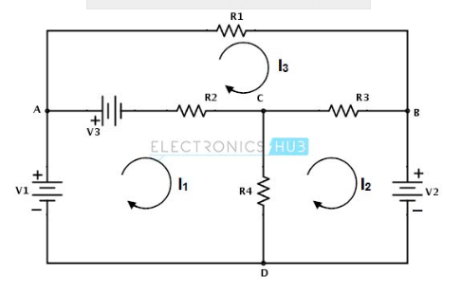

Secondly, for each mesh we have to apply KVL. By applying KVL around the first loop or mesh we get

V1 − V3 − R2 ( I1 − I 3 ) − R4 ( I1 − I 2 ) = 0

V1 − V3 = I1 ( R2 + R4 ) − I2R4 − I3R2 ………………(1)

Similarly, by applying KVL around second mesh we get,

−V2 − R3 ( I 2 − I 3 ) − R4 ( I 2 − I1 ) = 0

− V2 = − I1R4 + I 2 ( R3 + R4 ) − I 3 R3 ………………………(2)

And by applying KVL around third mesh or loop we get,

V3 − R1I 3 − R3( I 3 − I 2 ) − R2( I 3 − I1 ) = 0

V3 = − I1R2 − I2R3 + I3(R1 + R2 + R3) ………………………(3)

Therefore, by solving the above three equations we can obtain the mesh currents for each mesh in the given circuit.

### Example problems on mesh analysis:

**Example 1:**

Consider the below example in which we find the voltage across the 12A current source using mesh analysis. In the given circuit all the sources are current sources.

[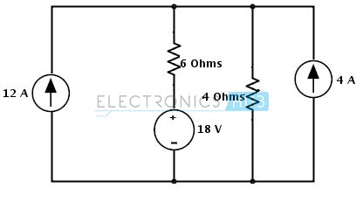](https://www.electronicshub.org/wp-content/uploads/2015/04/2.image2_.jpg)

**Step 1:** In the circuit there is a possibility to change the current source to a voltage source on right hand side source with parallel resistance. The current source is converted into a voltage source by placing the same value of resistor in series with a voltage source and the voltage in that source is determined as

Vs = Is Rs

= 4× 4 = 16 Volts

[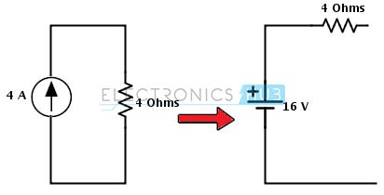](https://www.electronicshub.org/wp-content/uploads/2015/04/3.image3_1.jpg)

**Step 2:** Assign the branch currents as I1 and I2 to the respective branches or loops and represent the direction of currents as shown below.

[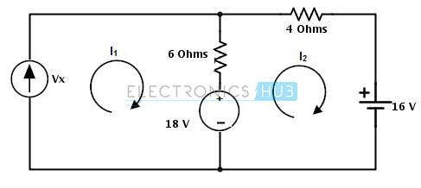](https://www.electronicshub.org/wp-content/uploads/2015/04/4.image4_.jpg)

**Step 3:** Apply the KVL to each mesh in the given circuit

**Mesh -1:**

Vx − 6 × (I1 − I 2) − 18 = 0

Substituting I1 = 12 A

Vx + 6I2 = 90…………………… (1)

**Mesh – 2:**

18 − 6 × ( I 2 − I1 ) − 4 × I 2 − 16 = 0

2 – 10 × I2 + 6(12) = 0

I2 = 74/ 10

= 7.4 Amps

Substituting in equation 1 we get

Vx = 90 – 44.4

= 45.6 Volts

**Example 2:**

Consider the below circuit where we determine the voltage across the current source and a branch current Iac. Assign the directions as shown below and note that current is assigned opposite to the source current in second loop.  
By applying KVL to the first mesh we get

V1 − R2 ( I1 − I 3 ) − R4 ( I1 − I 2 ) = 0

[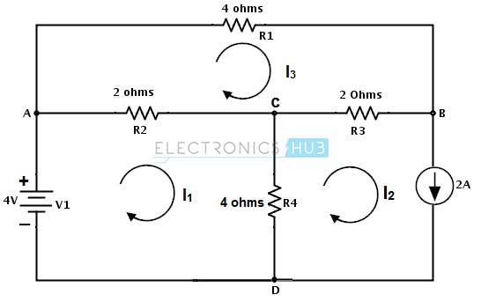](https://www.electronicshub.org/wp-content/uploads/2015/04/5.image5_.jpg)

4 – 2 I1 − 2I3 − 4I1 − 4I2 = 0

-6I1 − 2I3 = 4 ……………(1)

By applying KVL to the second mesh we get

−Vc − R4( I 2 − I1 ) − R3 ( I 2 − I 3 ) = 0

– Vc = 4I2 − 4I1 + 2I2 − 2I3 = 0

– Vc = – 4I1 + 6I2 – 2I3

But I2 = -2 A, then

– Vc = – 4I1 – 12 – 2 I3 ………………….(2)

By applying KVL to the third mesh we get

− R1 I 3 − R3 ( I 3 − I 2 ) − R2 ( I 3 − I1 ) = 0

−4 I3 − 2I3 + 2I2 − 2I3 + 2I1 = 0

− 8I3 − 4 + 2I1 = 0 (by substituting I2 = -2 A)

2I1 − 8I3 = 4 …………………(3)

By solving 1 and 3 equations we get I3 = -0.615 and I1 = 4.46

Therefore, the voltage Vc = 4 (4.46) + 12 + 2(-0.615)

Vc = 28.61 V

And the branch current Iac = I1- I3

Iac = 5.075 amps

Likewise we can find every branch current using the mesh analysis.

1. **Introduction to MATLAB:**

* MATLAB is widely used in all areas of applied mathematics, in education and research at universities, and in the industry.
* MATLAB stands for MATrix LABoratory and the software is built up around vectors and matrices.
* This makes the software particularly useful for linear algebra but MATLAB is also a great tool for solving algebraic and differential equations and for numerical integration.
* MATLAB has powerful graphic tools and can produce nice pictures in both 2D and 3D.
* It is also a programming language, and is one of the easiest programming languages for writing mathematical programs. MATLAB also has some tool boxes useful for signal processing, image processing, optimization, etc.

### How to start MATLAB

* **Mac:**Double-click on the icon for MATLAB.
* **PC:**Choose the submenu "Programs" from the "Start" menu. From the "Programs" menu, open the "MATLAB" submenu. From the "MATLAB" submenu, choose "MATLAB".
* **Unix:**At the prompt, type matlab.
* You can quit MATLAB by typing exit in the command window.

1. **MATLAB CODES:**

clc

clear all

a = [40 -10 -30;

-10 30 -5;

-30 -5 65];

v =[10 0 0]';

I= inv(a)*v;

fprintf('current through I1 is %.4f \n',I(1))

fprintf('current through I2 is %.4f \n',I(2))

fprintf('current through I3 is %.4f\n',I(3))

%first calculate current through RB(5 ohm)

IRB=I(3)-I(2);

fprintf('current through RB is %.4f\n', IRB)

%current through 10 ohm resistor

I(10)=I(1)-I(2);

fprintf('Current across 10 ohm resistor is %.4f \n',I(10))

%current through 30 ohm resistor

I(30)=I(1)-I(3);

fprintf('current across 30-ohm resistor is %.4f \n',I(30))

**RESULTS(MATLAB)**

current through I1 is 0.4753

current through I2 is 0.1975

current through I3 is 0.2346

current throug RB is 0.0370

Current across 10 ohm resistor is 0.2778

current across 30 ohm resistor is 0.2407

1. **COMPARISON (MATLAB VS PSPICE)**

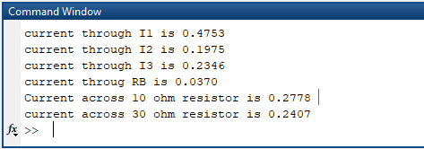

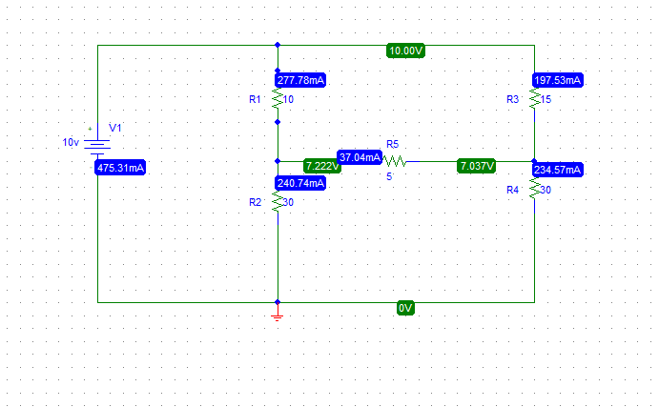

1. **CONCLUSION:**

From the above figure we have find the values of currents IRB, I(10), I(30) by using MATLAB software of complex circuit.

Hence from this lab I have got:

* Experience Over MATLAB environment
* Analyzing Complex Circuits using MATLAB
* Writing MATLAB.

**THE END**